Test Case: tc003_SPX_Dev5_Crear_Requisicion_Spot_Tipo_Cobro_CC_Urgent
Step 1 - Enter username and password and click to button Enter : Credentials Entered
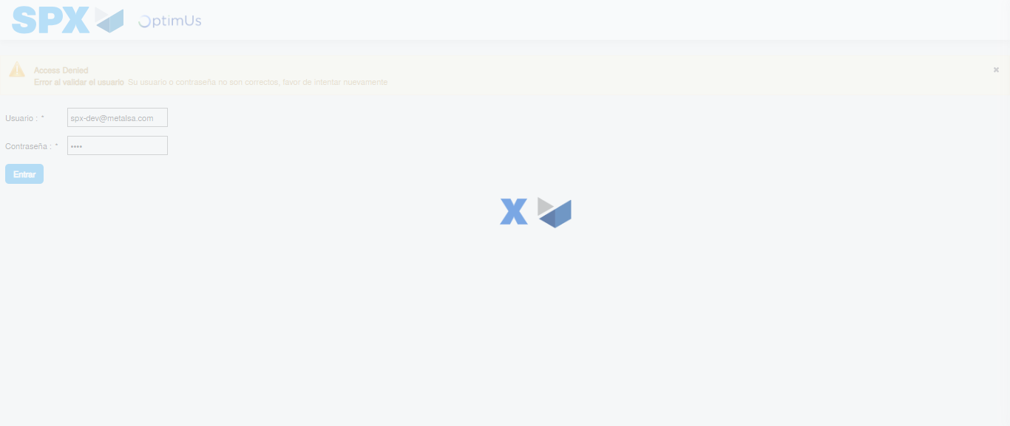Image file-name: QC_Testing-tc003_SPX_Dev5_Crear_Requisicion_Spot_Tipo_Cobro_CC_Urgent-1782239456786

Step 2 - Select to UEN and Access to Spot Buy Requisitions : UEN Correctly selected and Correct access
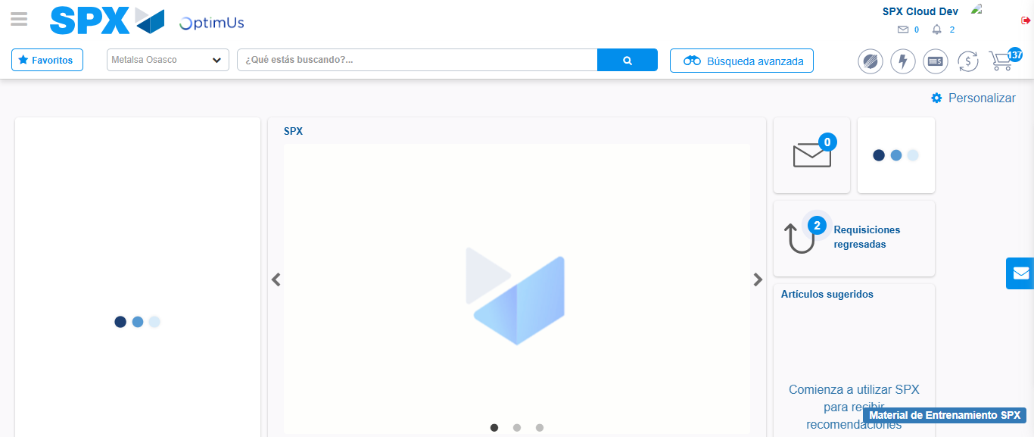Image file-name: QC_Testing-tc003_SPX_Dev5_Crear_Requisicion_Spot_Tipo_Cobro_CC_Urgent-1782239483326

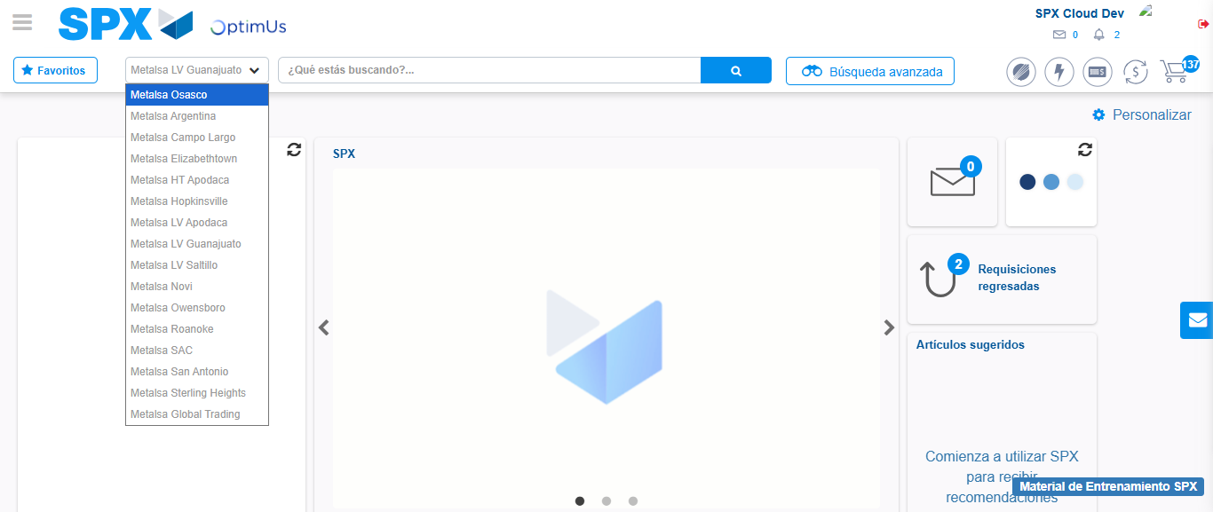Image file-name: QC_Testing-tc003_SPX_Dev5_Crear_Requisicion_Spot_Tipo_Cobro_CC_Urgent-1782239485817

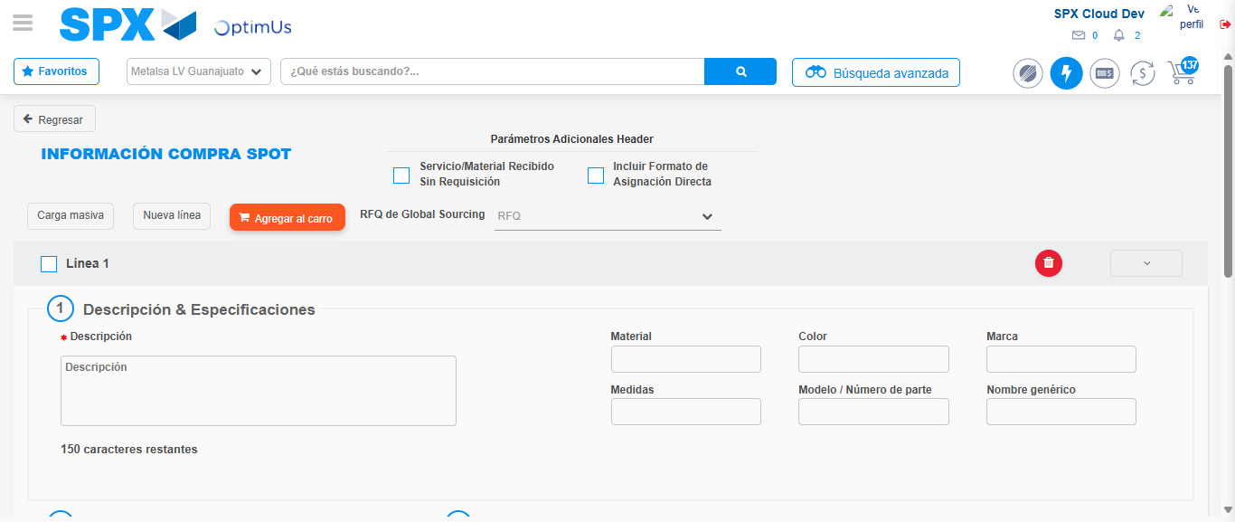Image file-name: QC_Testing-tc003_SPX_Dev5_Crear_Requisicion_Spot_Tipo_Cobro_CC_Urgent-1782239508472

Step 3 - Data Capture Spot Buy Requisition: Data captured correctly
Image file-name: QC_Testing-tc003_SPX_Dev5_Crear_Requisicion_Spot_Tipo_Cobro_CC_Urgent-1782239508710

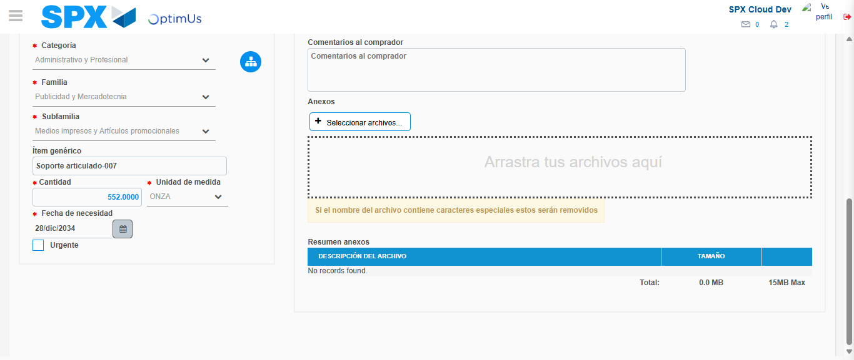Image file-name: QC_Testing-tc003_SPX_Dev5_Crear_Requisicion_Spot_Tipo_Cobro_CC_Urgent-1782239518368

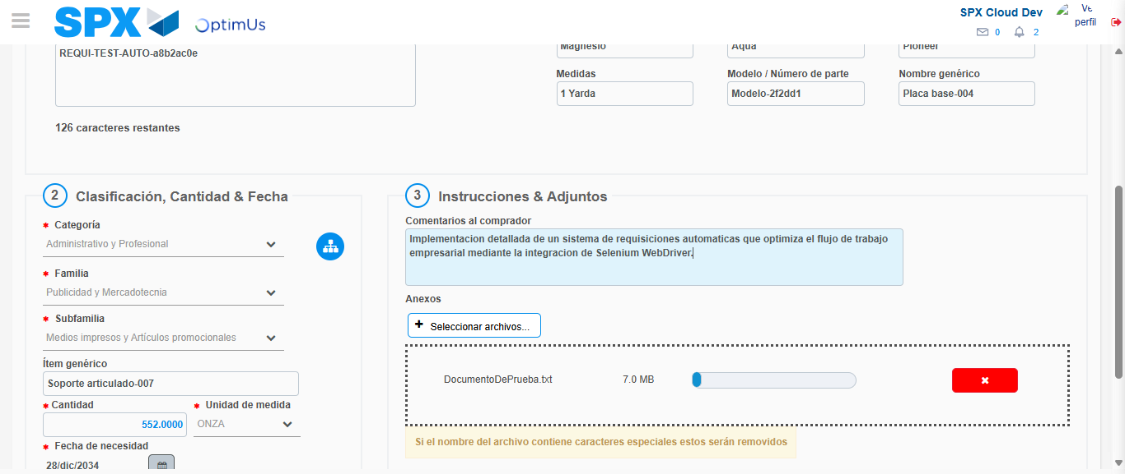Image file-name: QC_Testing-tc003_SPX_Dev5_Crear_Requisicion_Spot_Tipo_Cobro_CC_Urgent-1782239519180

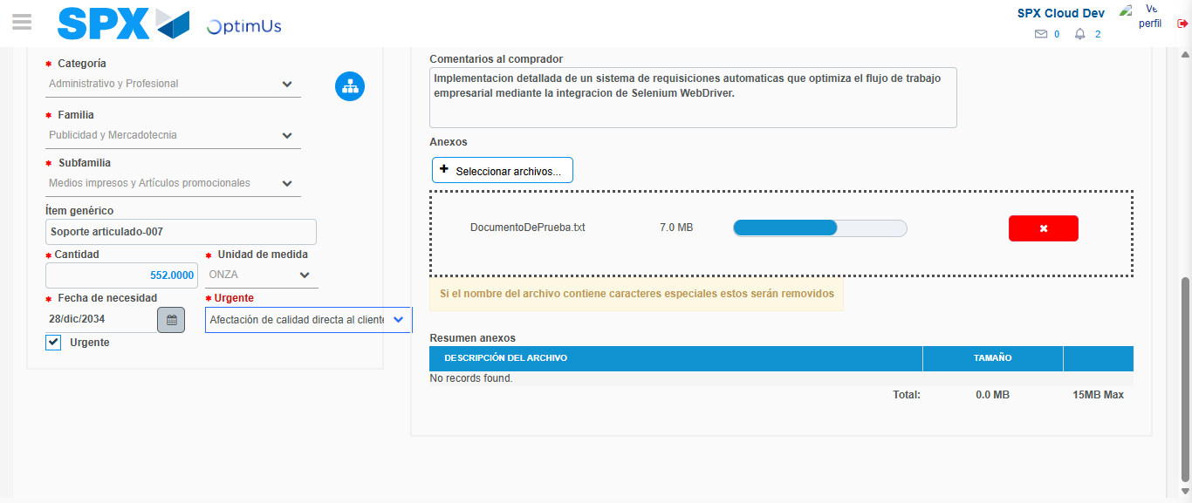Image file-name: QC_Testing-tc003_SPX_Dev5_Crear_Requisicion_Spot_Tipo_Cobro_CC_Urgent-1782239522749

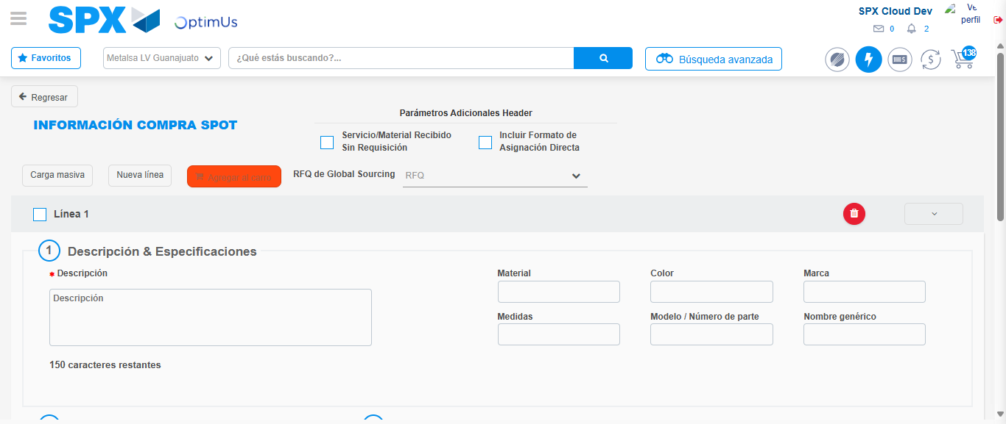Image file-name: QC_Testing-tc003_SPX_Dev5_Crear_Requisicion_Spot_Tipo_Cobro_CC_Urgent-1782239527315

Step 4 - Select to Requisition: Requisition Correctly selected
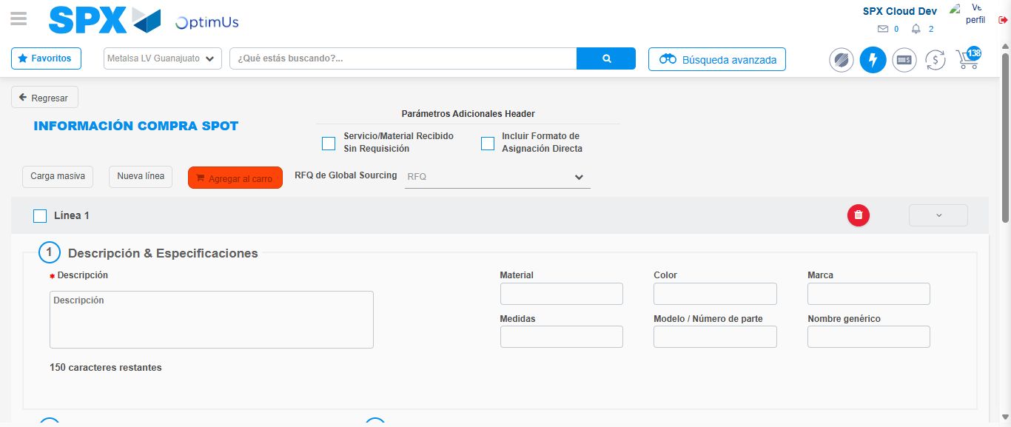Image file-name: QC_Testing-tc003_SPX_Dev5_Crear_Requisicion_Spot_Tipo_Cobro_CC_Urgent-1782239527520

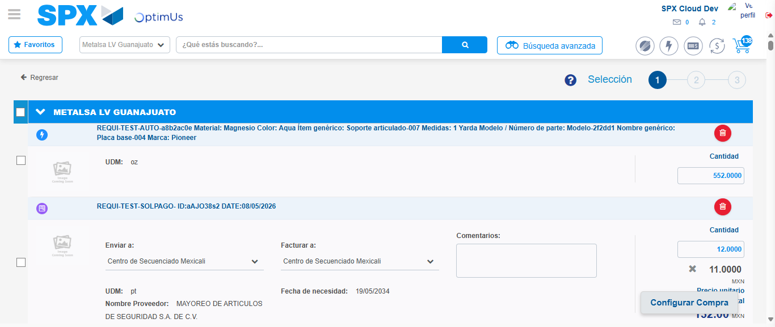Image file-name: QC_Testing-tc003_SPX_Dev5_Crear_Requisicion_Spot_Tipo_Cobro_CC_Urgent-1782239539949

Image file-name: QC_Testing-tc003_SPX_Dev5_Crear_Requisicion_Spot_Tipo_Cobro_CC_Urgent-1782239540161

Image file-name: QC_Testing-tc003_SPX_Dev5_Crear_Requisicion_Spot_Tipo_Cobro_CC_Urgent-1782239540384

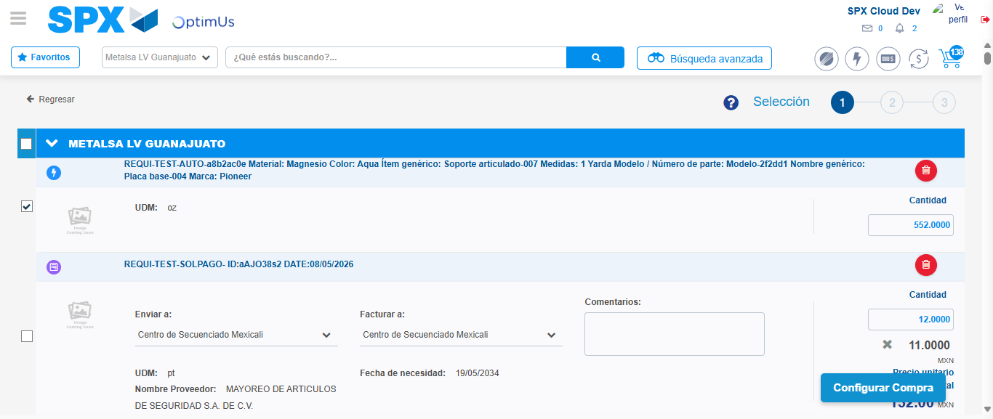Image file-name: QC_Testing-tc003_SPX_Dev5_Crear_Requisicion_Spot_Tipo_Cobro_CC_Urgent-1782239542266

Step 5 - Select Type Account For Requisition: Type Account Correctly selected
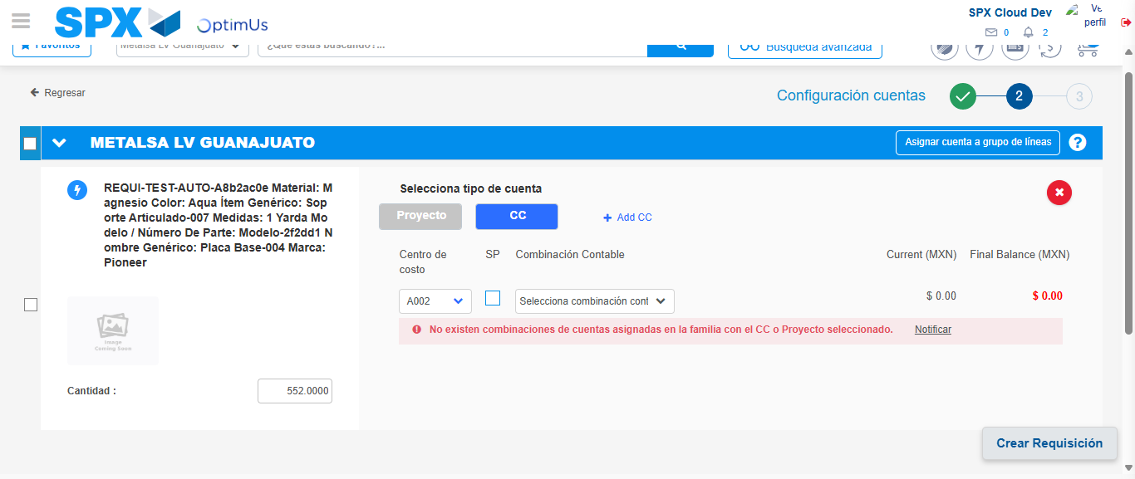Image file-name: QC_Testing-tc003_SPX_Dev5_Crear_Requisicion_Spot_Tipo_Cobro_CC_Urgent-1782239558050

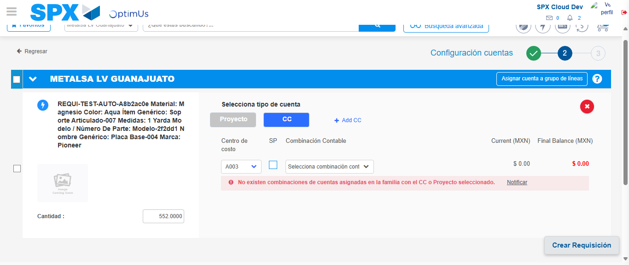Image file-name: QC_Testing-tc003_SPX_Dev5_Crear_Requisicion_Spot_Tipo_Cobro_CC_Urgent-1782239563314

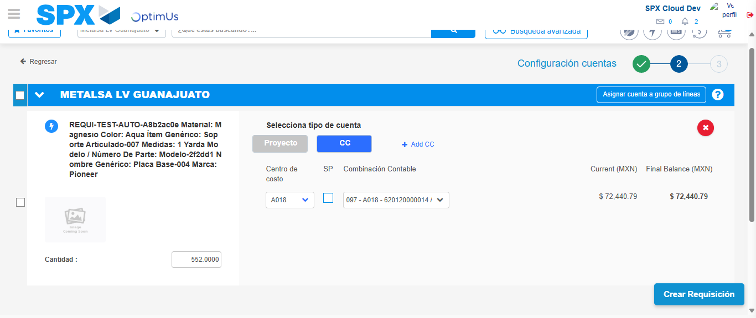Image file-name: QC_Testing-tc003_SPX_Dev5_Crear_Requisicion_Spot_Tipo_Cobro_CC_Urgent-1782239568541

Image file-name: QC_Testing-tc003_SPX_Dev5_Crear_Requisicion_Spot_Tipo_Cobro_CC_Urgent-1782239568706

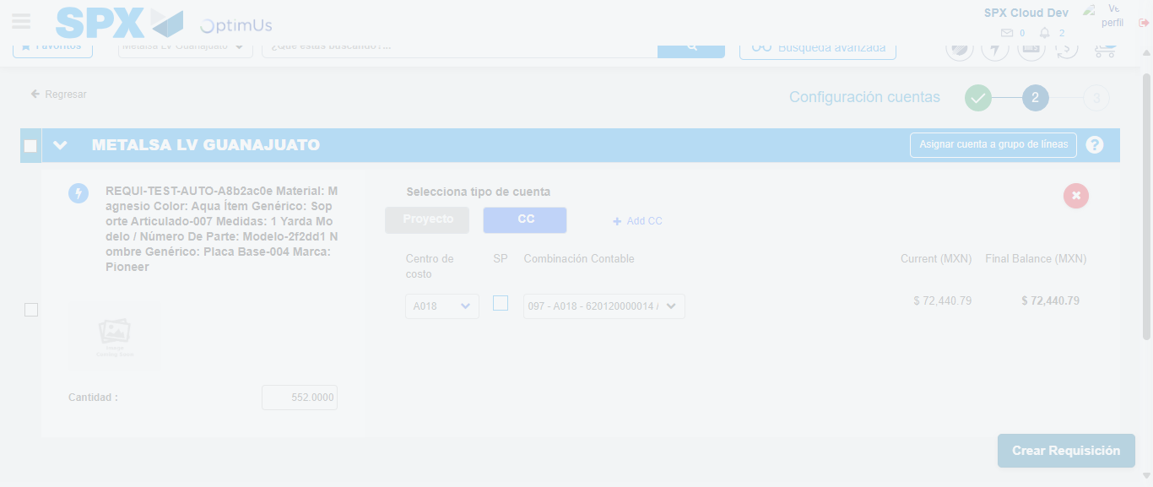Image file-name: QC_Testing-tc003_SPX_Dev5_Crear_Requisicion_Spot_Tipo_Cobro_CC_Urgent-1782239569096

Step 6 - Accept to Requisition: Requisition Accepted
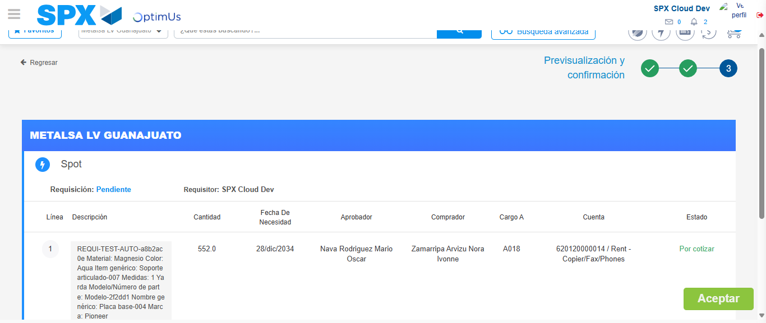Image file-name: QC_Testing-tc003_SPX_Dev5_Crear_Requisicion_Spot_Tipo_Cobro_CC_Urgent-1782239569909

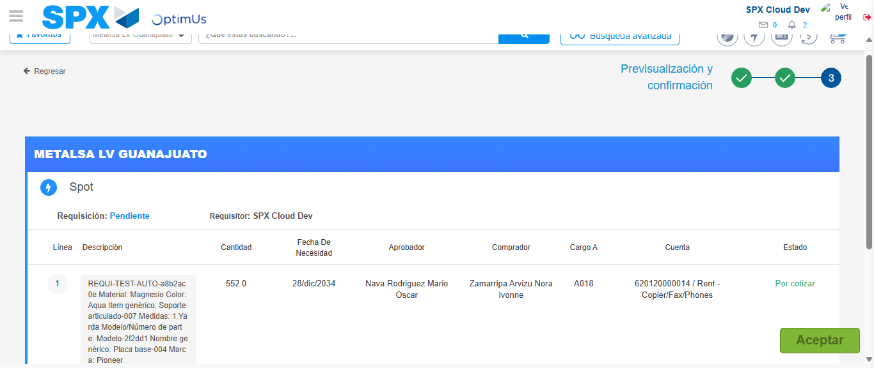Image file-name: QC_Testing-tc003_SPX_Dev5_Crear_Requisicion_Spot_Tipo_Cobro_CC_Urgent-1782239570182

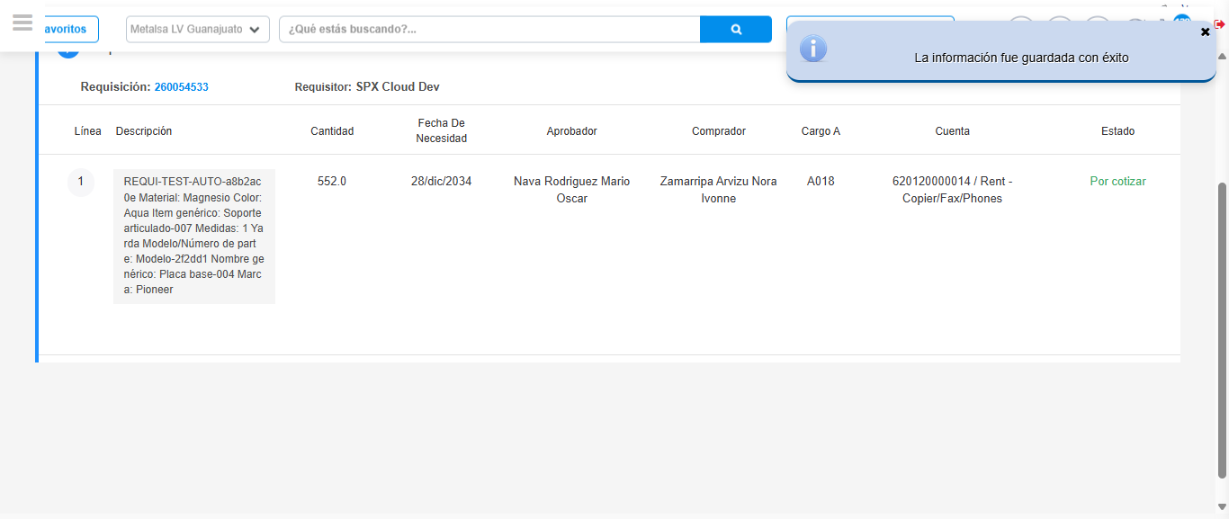Image file-name: QC_Testing-tc003_SPX_Dev5_Crear_Requisicion_Spot_Tipo_Cobro_CC_Urgent-1782239573293

Step 7 - Return to Main Page SPX : Return to Main Page SPX
Image file-name: QC_Testing-tc003_SPX_Dev5_Crear_Requisicion_Spot_Tipo_Cobro_CC_Urgent-1782239483326

Image file-name: QC_Testing-tc003_SPX_Dev5_Crear_Requisicion_Spot_Tipo_Cobro_CC_Urgent-1782239485817

Image file-name: QC_Testing-tc003_SPX_Dev5_Crear_Requisicion_Spot_Tipo_Cobro_CC_Urgent-1782239508472

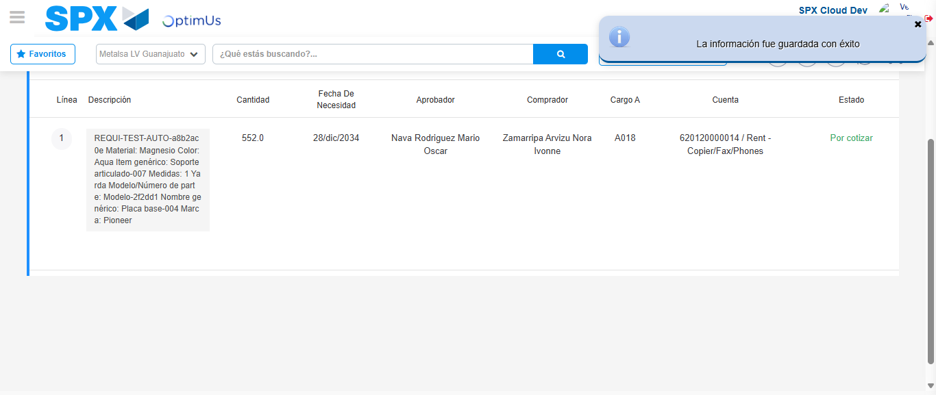Image file-name: QC_Testing-tc003_SPX_Dev5_Crear_Requisicion_Spot_Tipo_Cobro_CC_Urgent-1782239575512

Image file-name: QC_Testing-tc003_SPX_Dev5_Crear_Requisicion_Spot_Tipo_Cobro_CC_Urgent-1782239575666

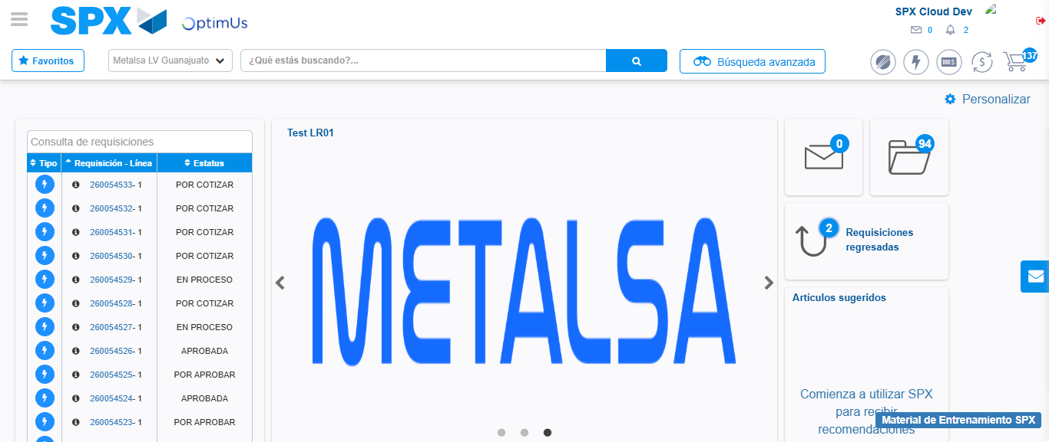Image file-name: QC_Testing-tc003_SPX_Dev5_Crear_Requisicion_Spot_Tipo_Cobro_CC_Urgent-1782239596768

Step 8 - Log Out : Log Out SPX
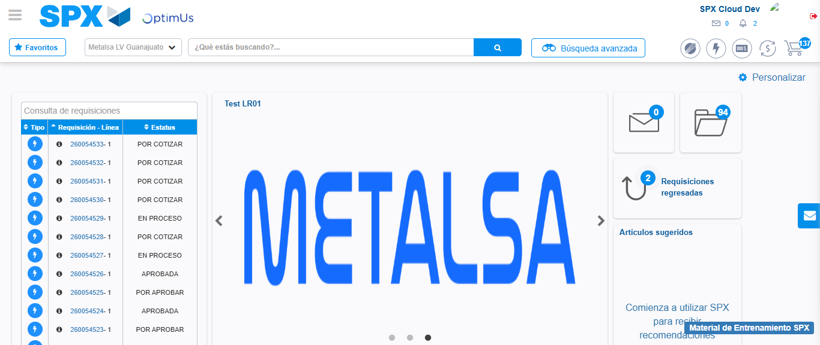Image file-name: QC_Testing-tc003_SPX_Dev5_Crear_Requisicion_Spot_Tipo_Cobro_CC_Urgent-1782239597098

